AUV Dorado zooplankton sampling goals, May-June 2012 (Vrijenhoek):

Sampling scenarios currently envisioned for this year include the following:
1) Sampling interface waters of upwelling fronts
2) Sampling inside and/or around sub-surface ammonia maxima

As mentioned previously, we’d like 1) to be our primary focus with respect to Rajan/Ryan/Vrijenhoek collaboration in 2012 and possibly beyond.
After some discussion, we are rethinking an initial proposal trigger all 10 gulpers inside the upwelling front itself, to the exclusion of reference samples from outside the frontal environment. John Ryan raised the excellent point that reference samples are desirable because without them, it will be difficult to make an honest comparison among samples representing different water types (e.g. inside the front, outside the front). Therefore our sampling goals for upwelling fronts remain the same as previously (numbers refer to gulper bottles):

0–2: collect stratified water from the near-shore side of the upwelling filament (n = 3).

3–6: collect water from the upwelling front (n = 4).

7–9: collect water from the core of the upwelling filament (n = 3).
Regarding the environmental parameters defining a typical upwelling
front and surrounding environment, the following figure (from mission Dorado389_2011_164_05_164_05) provides a good graphic example:

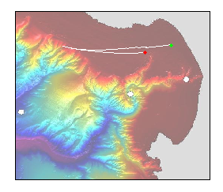

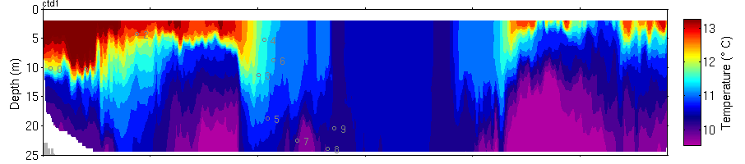
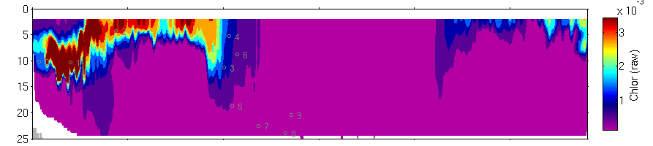
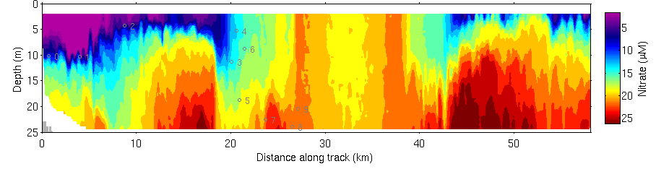

Figure. AUV Dorado mission 2011_164_05 upwelling filament survey, June 2011. Dorado successfully surveyed and acquired water samples from three water types across an upwelling filament originating north of Monterey Bay. The AUV transect location within the bay is indicated.

Complete AUV Dorodo data for the above hydrographic example is provided here (see e-mail attachment: Dorado389_2011_164_05_164_05.txt).

Additionally, the most recent AUV water sample data from frontal surveys in 2011, in addition to associated biological data, is currently available on confluence, here:

https://oceana.mbari.org/confluence/pages/viewpageattachments.action?pageId=18580167

Please use the most recent file entitled, “2011_AUVdorado_Samples.xlsx” with comment, “All 2011 AUV Dorado water sample data - 3/16/2012 update”.

Also note that we have yet to target and acquire high chlorophyll water samples specifically from within an upwelling front. Doing so, and at a range of depths, is another or our top tier future goals.

Please contact us with specific questions; we look forward to further discussion.

