Reward
The Monterey Bay Aquarium Research Institute is looking for a telemetry buoy that released from a Sediment Transport Event Detector (STED) that was located in the axis of the Monterey Canyon.

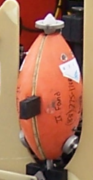

Cynthia Edgerly found the buoy near Pajaro Dunes on 13 January 2009. Brett Hobson paid the $200 reward to Cynthia.

Cynthia Edgerly
854 San Miguel Canyon Rd.
Watsonville, CA 95076
Ph 831 768-9308

